Note: The main functionality of the page should be ready by 21/09, so we will be able then to clone the page to different domains and localize the content. Some small design fixes can be done afterwards. Launch date for all domains (where we get localized content) on 26/09.

Feedback on the first draft:

Umbraco side:

* Pricing accordion – panel -> could we make it automated that every second feature (PricingAccordionCheckmarkRow) has a different background color?
* The names in the PricingAccordionCheckmarkRow should be changed from visibleCheck1,2,3,4 to names of the pricing packages – Essential, Standard...

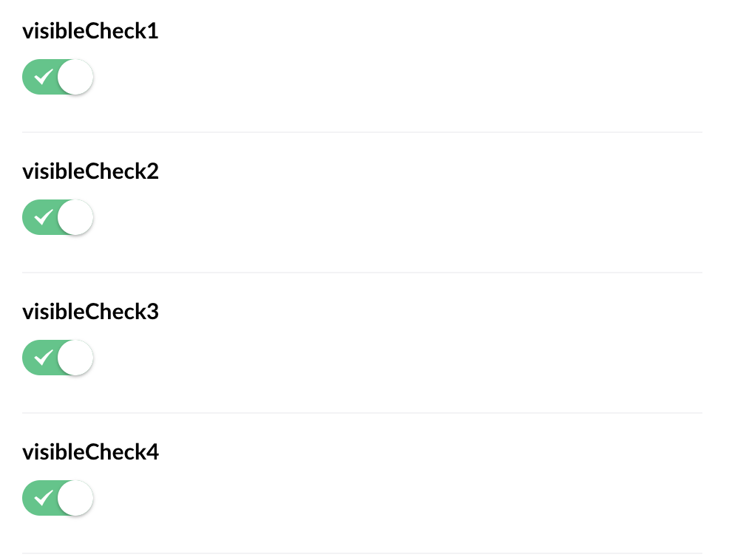

Visual side:

* The top section looks quite big, maybe we could make it smaller, like on the customer cases page (https://www.tamigo.de/customer-cases)?
* Font size should be the same as on other pages ( h1 – Desktop: 2.8rem & Mobile: 4.5rem, h2 – Desktop: 2.2 rem & Mobile: 4rem, p – Desktop: 1.4rem & Mobile: 2.6rem)



* The font size & line-height of the copy underneath the package name on desktop should be smaller. (1.1 rem with line-height of 1.3) Copy should be in two lines (possibility of pushing the words to the next line to make it aligned)
* Font weight of the package names should be bolder (medium)
* All boxes (packages) must be the same height and width, they should be top-aligned and have the same padding around the edges.
* CTAs should scale up on hover, the same ways as on other pages, the copy shouldn’t be underlined. They should be aligned with the copy within the boxes.
* There should be less white space between the boxes.
* The smaller screen size version must be fixed, the boxes should always be aligned and the same height. Also, the CTA buttons need to be aligned with the copy in the box. The copy within the box shouldn’t overlay.

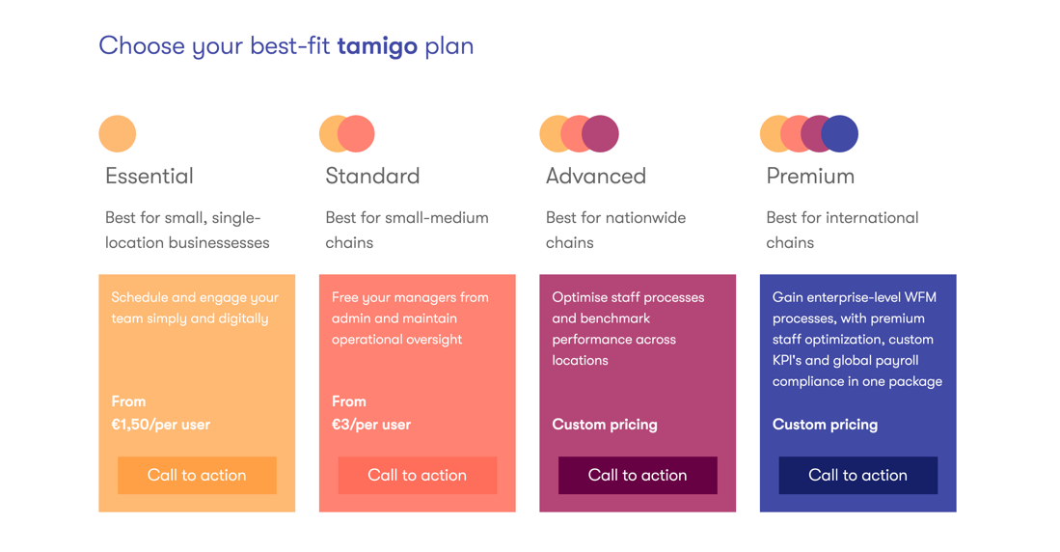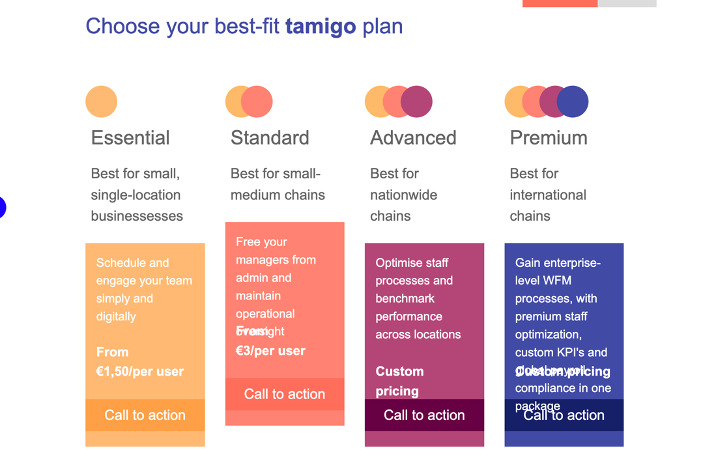

* Boxes with the package's names should have less padding on top & bottom, the copy within them should be centered. On smaller screens the copy should fit within the box and be centered. Boxes should scale proportionally. We planned to have these four boxes with the different plans as a sticky module, will that be the case?
* We are missing a blue table around the list of features.
* Copy should never go over the checkmarks, if it is too long it should expand to the next line (we should consider smaller font-size – keeping in mind localizations)

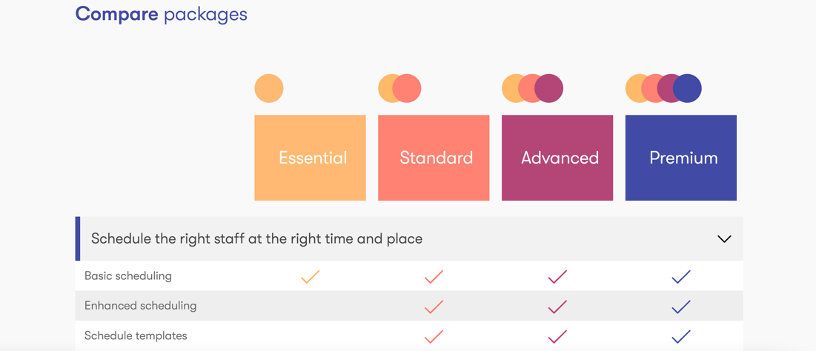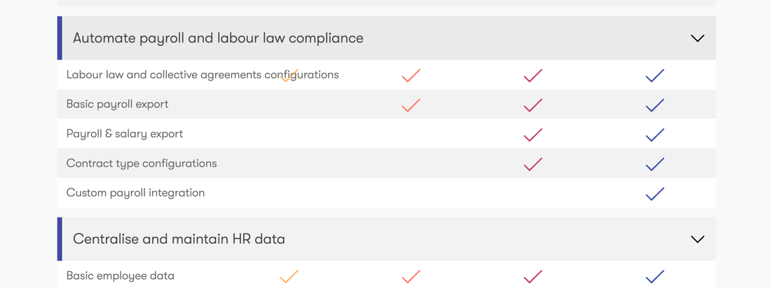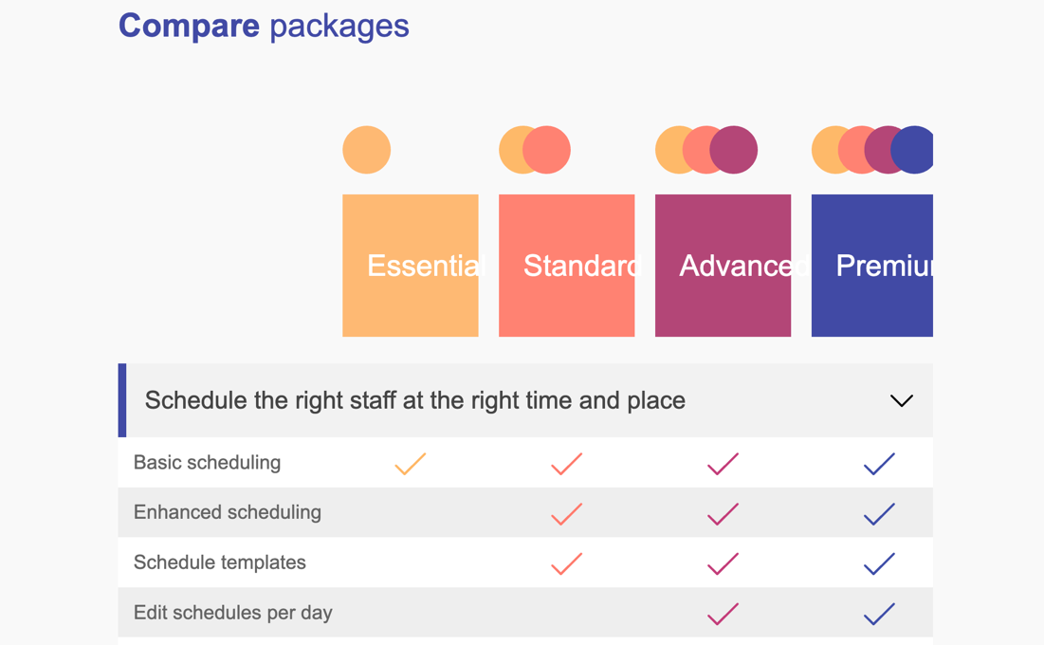

* Can we get rid of a grey overlay on logos?



* The image & copy section is not aligned. Image should be vertically centered with the copy.
* Too much space at the bottom of the module.
* On smaller screens the image looks very small, could we fix it somehow, maybe upload another image for more narrow screens?



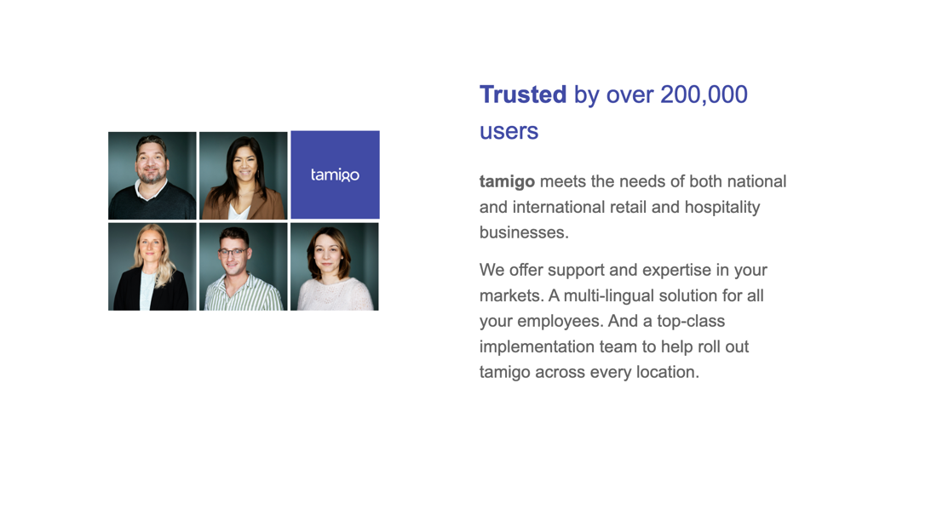

* CTAs should scale up on hover, the same ways as on other pages, the copy shouldn’t be underlined.

